Project Design Phase-II
Technology Stack (Architecture & Stack)

Date | 05 October 2026
Team ID | SWTID-2026-4248
Project Name | LearnMate AI StudyBuddy
Maximum Marks | 4 Marks

Technical Architecture:
The Deliverable shall include the architectural diagram as below and the information as per the table1 & table 2
LearnMate AI StudyBuddy – Technical Architecture & Technology Stack
Reference: LearnMate Complete Project Documentation and project source code.
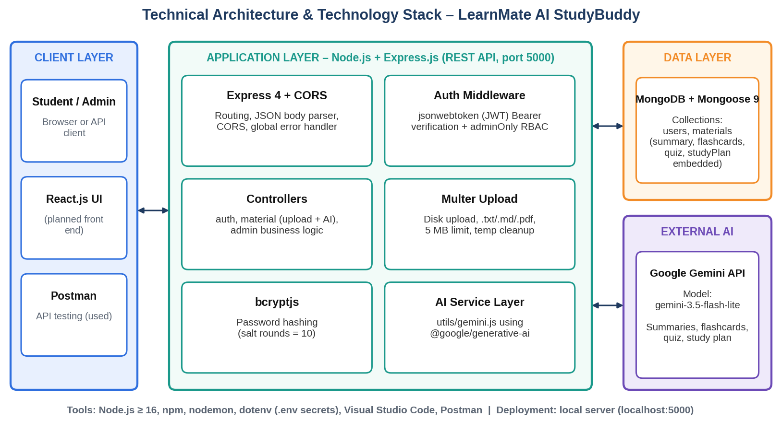

Table-1 : Components & Technologies:
S.No | Component | Description | Technology
 | User Interface | Clients call the REST API; tested through Postman, React.js front end planned | Postman, REST clients, React.js (planned)
 | Application Logic-1 | Routing, controllers and business logic for auth, materials and admin | Node.js (v16+), Express.js
 | Application Logic-2 | Authentication and authorization: JWT access/refresh tokens, password hashing, role check | jsonwebtoken, bcryptjs
 | Application Logic-3 | Upload handling and validation of study files (.txt, .md, .pdf, 5 MB) | Multer
 | Database | NoSQL collections users and materials (summary, flashcards, quiz, studyPlan stored with each material) | MongoDB, Mongoose ODM
 | Cloud Database | Optional managed database through MONGO_URI (local MongoDB used in development) | MongoDB Atlas (optional)
 | File Storage | Uploaded file stored temporarily in uploads/ and deleted after its text is saved to MongoDB | Local filesystem (Multer disk storage)
 | External API-1 | Generative AI service used to create summaries, flashcards, quizzes and study plans | Google Gemini API (@google/generative-ai)
 | External API-2 | Not required in the current release | —
 | Machine Learning Model | Pre-trained large language model used through prompts for content generation | gemini-3.5-flash-lite
 | Infrastructure (Server / Cloud) | Local server on port 5000. Local: Windows/macOS/Linux, Intel i5 8th gen / Ryzen 5, 8 GB RAM, 1 GB storage. Cloud deployment possible later. | Local (Node.js, nodemon, dotenv, VS Code)

Table-2: Application Characteristics:
S.No | Characteristics | Description | Technology
 | Open-Source Frameworks | Open-source frameworks and libraries used | Node.js, Express.js, Mongoose, Multer, cors, dotenv, nodemon
 | Security Implementations | JWT Bearer authentication, bcrypt password hashing, role-based access control, upload validation, CORS policy, secrets in .env | JWT, bcryptjs, RBAC, OWASP-aligned practices
 | Scalable Architecture | Three-tier modular MVC design (API / business logic / database) with stateless authentication that supports horizontal scaling | Node.js, Express.js, MongoDB
 | Availability | Stateless API instances can run behind a load balancer; a replicated MongoDB cluster avoids a single point of failure | Load balancer, MongoDB replica set (planned)
 | Performance | Asynchronous non-blocking I/O, lean list queries (content and AI fields excluded), 5 MB upload cap; caching and CDN can be added for the front end | Node.js event loop, Mongoose select(), Gemini flash-lite model

References:
https://c4model.com/
https://developer.ibm.com/patterns/online-order-processing-system-during-pandemic/
https://www.ibm.com/cloud/architecture
https://aws.amazon.com/architecture
https://medium.com/the-internal-startup/how-to-draw-useful-technical-architecture-diagrams-2d20c9fda90d

